**PROJECT-NAME: VISION RAYS**

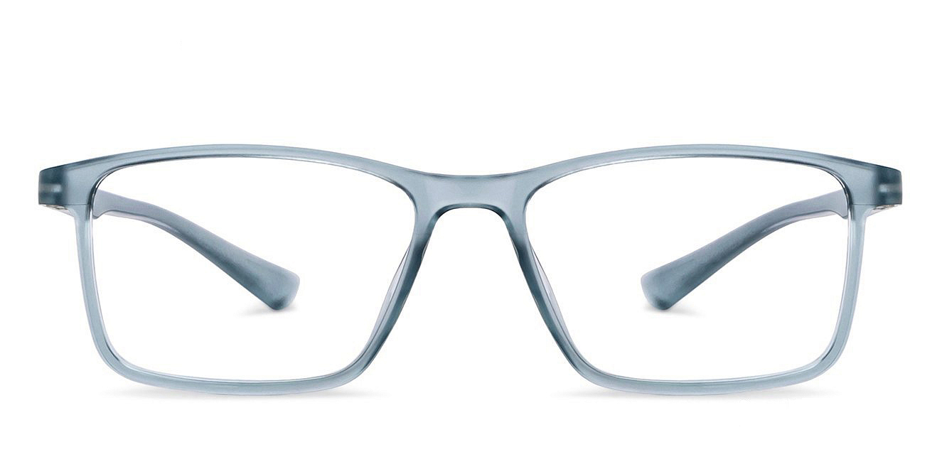

**OVERVIEW:** It’s an e-commerce website for All types of Eyewear items.

1. **HOME PAGE:**

# LOGO

# ICONS - (WISHLIST, ADD TO CART)

# SEARCH BAR

# SLIDERS WITH ARROWS - (IMAGES)

# DEALS - (IMAGES)

# FEATURED - (IMAGES)

# TRENDING - (IMAGES)

# FOOTER – ( About,CONTACT US , HELPLINES. )

1. **PRODUCT DESCRIPTION PAGE:**

# Description of Selected Product.

# More Images of that Product.

# Detail View.

1. **PAYMENT PAGE:**

# ADDRESS SELECTION

# PAYMENT METHOD - (PHONEPE , GOOGLE PAY , BHIM UPI, COD , CREDIT/DEBIT CARD , NET - BANKING , EMI , PAYTM).